EDA WITH VISUALIZATION

Theophila Murphy S

DE-Batch 6

VISUALIZATION-1

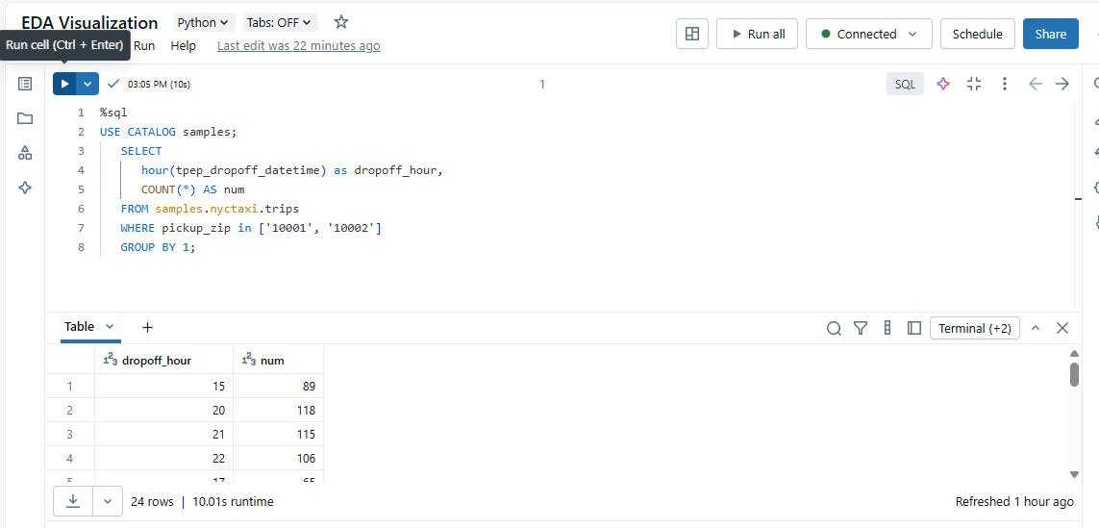

VISUALIZATION-2

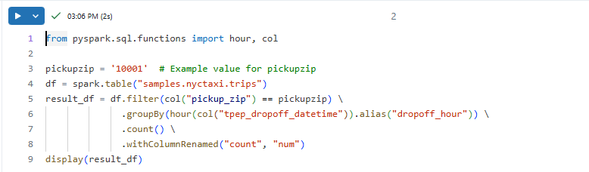

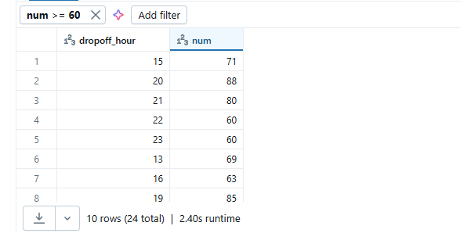

VISUALIZATION-3



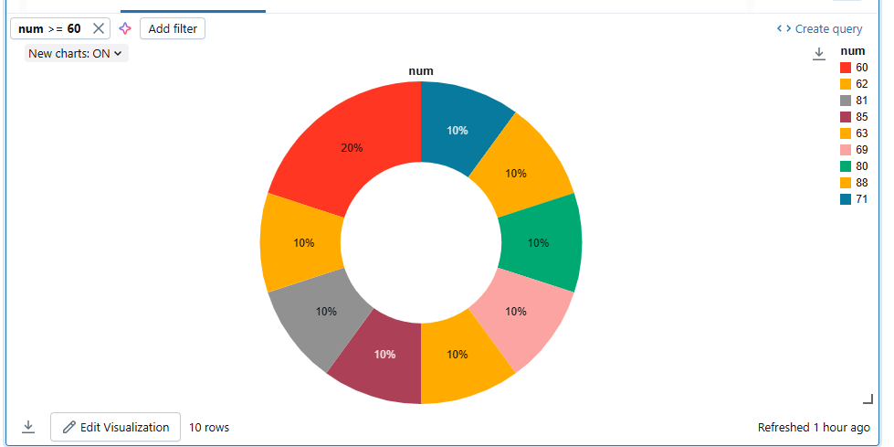  
VISUALIZATION-4



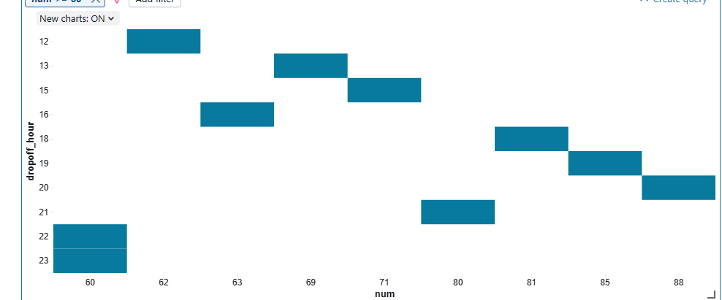

VISUALIZATION-5



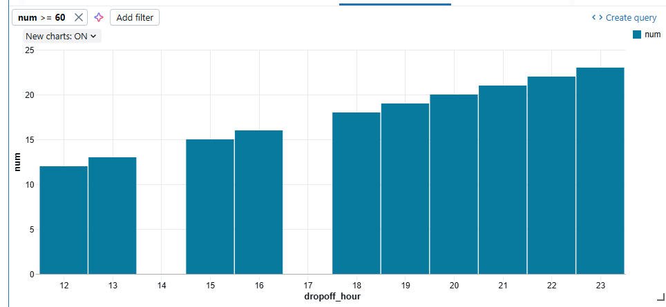

VISUALIZATION-6



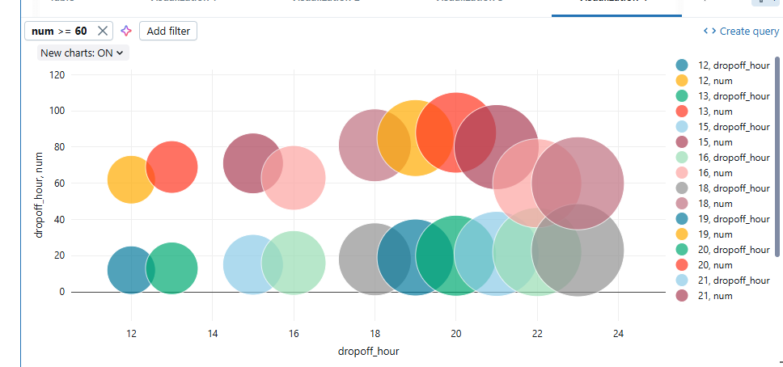

VISUALIZATION-7

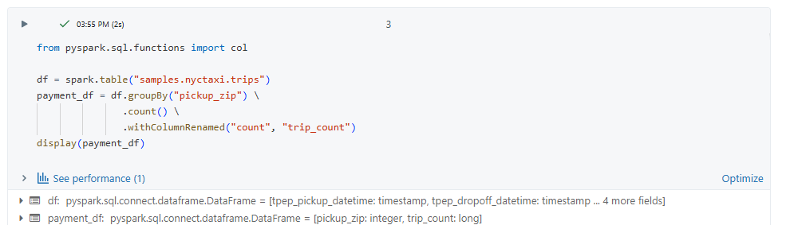

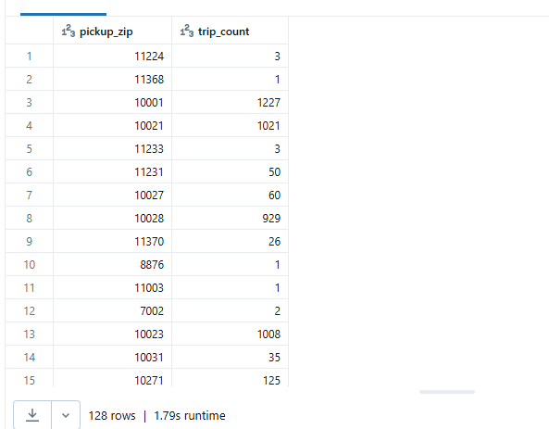

VISUALIZATION-8



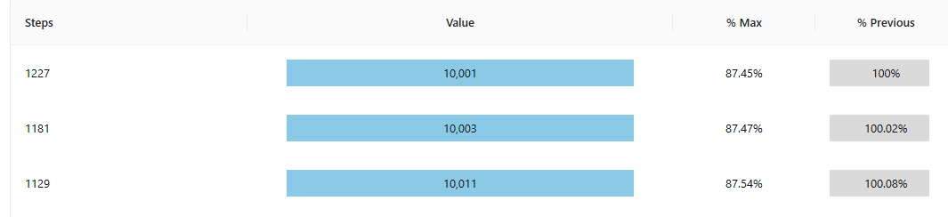

VISUALIZATION-9



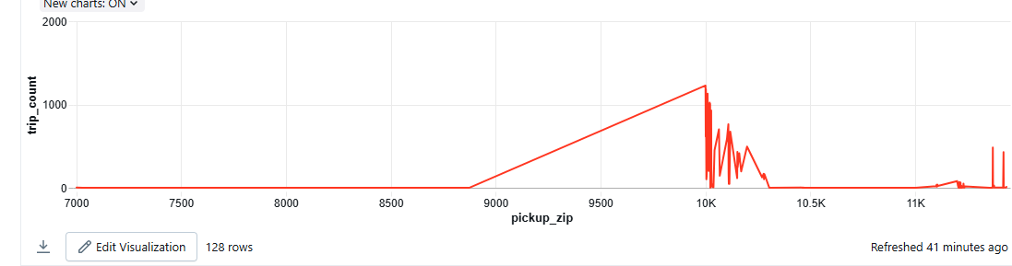

VISUALIZATION-10



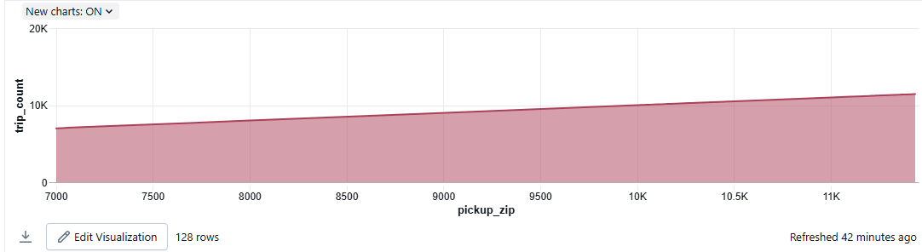

VISUALIZATION-11



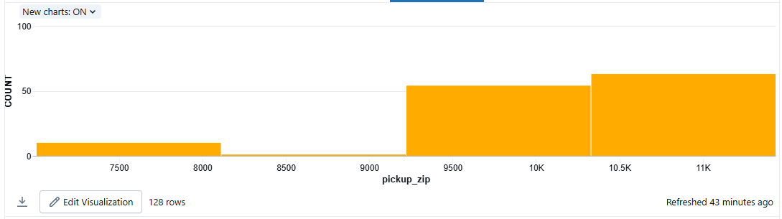

VISUALIZATION-12

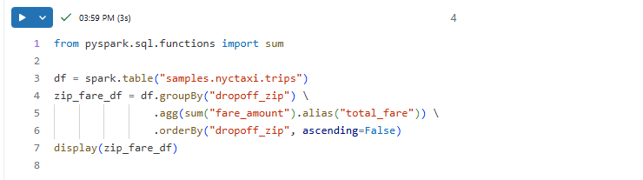

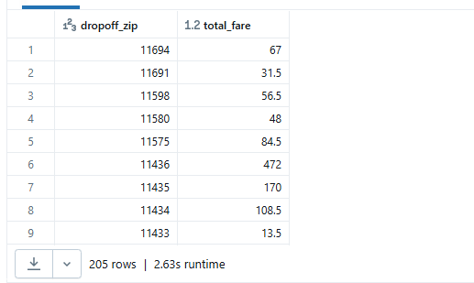

VISUALIZATION-13





VISUALIZATION-14



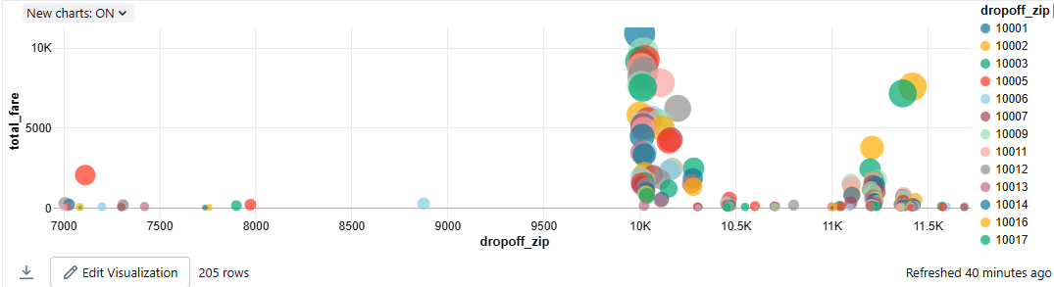

VISUALIZATION-15



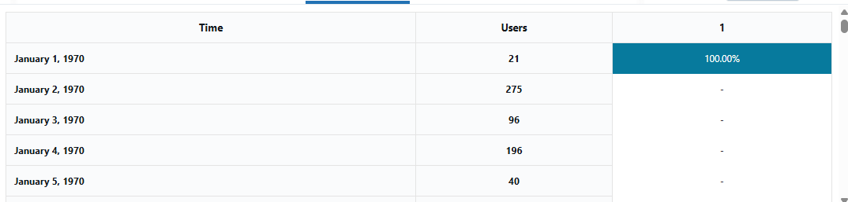

VISUALIZATION-16





VISUALIZATION-17



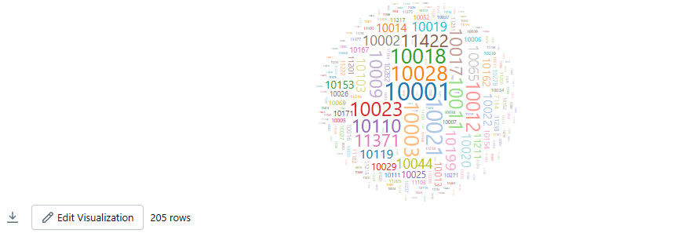

VISUALIZATION-18

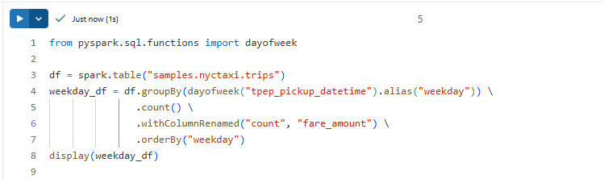

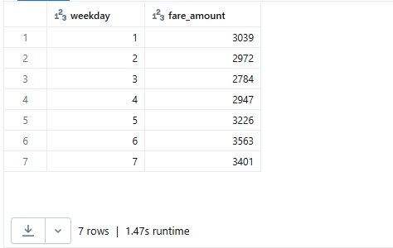

VISUALIZATION-19



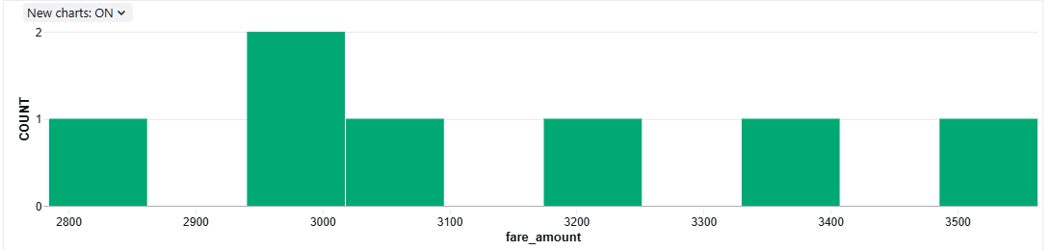

VISUALIZATION-20



